Milton Kioko Kyuli
Kaseve Primary School
P.O. Box 1,
Ithanga via Thika Kenya.
E-MAIL :milkoli68@gmail.com
: miltokoko@gmail.com
: +254 721 663 986
Daughter Mary : +254 728 038 394

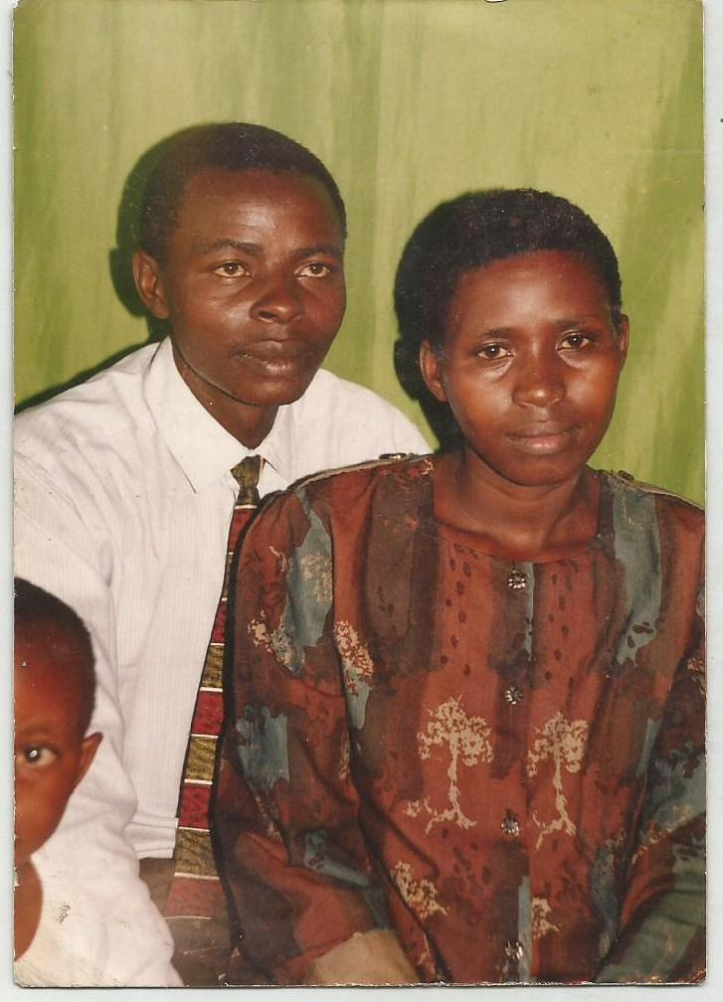

Father Milton & Mother Winnie & Face of Edward
Father Milton Kevin Mary Martin Mother
Kevin Mother Last born son Martin in 0ur house compound
Martin Mary Kevin

Edward-First born-Form 4 drop out
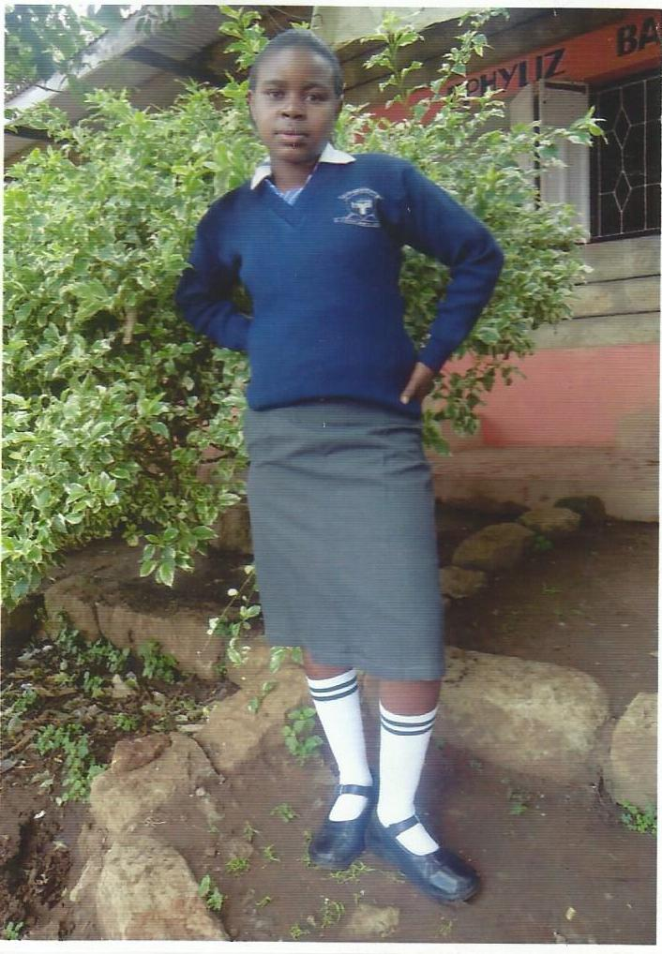
Mary—secondary
Mary—Primary
Kevin—Third born
Martin---Last born
Kevin when hunting for antelope carrying quiver & arrows
Martin Riding Biscycle at home

